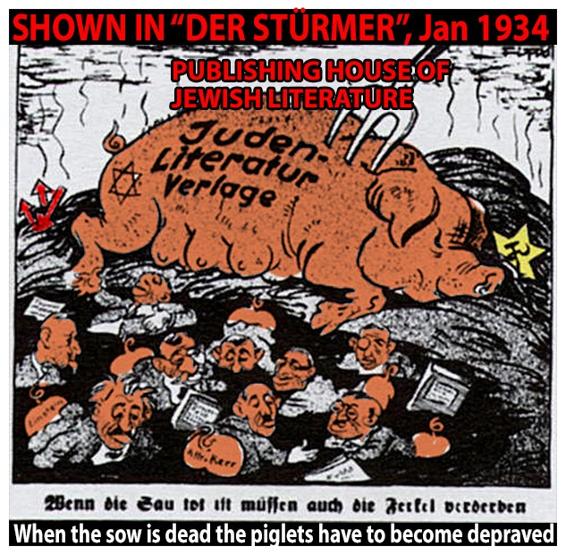

**DEEP QUESTIONS**:

**1.**

**2.**

**3.**

**Resolution of a Municipal Council in the Bernkastel District,**

## August 13, 1935

Judaism, which has brought such misfortune on our German Fatherland, is today once again rearing its head more boldly than ever. There parasites on the German body politic underestimate our sense of decency and are again making themselves at home within National Socialist Germany, which they hate so much, and are again pouring out their Jewish impudence and vulgarity.

In recognizing this situation, we have resolved to act accordingly:

• All city exits will be fitted with signs bearing the inscription: Jews Not Wanted Here.

• The journal *Der Sturmer*, on display in the news paper display box in the town center, will be

recommended to all citizens.

• No craftsman, businessman, or any other countryman will receive work contracts from the

community and will immediately forfeit entitlement to the use and enjoyment of communal

property if he or members of his family continue to traffic with Jews; that is, if he supports their

businesses.

• Making purchases from Jews, employing Jewish physicians or lawyers is tantamount to

committing a traitorous act against the German people and nation.