IB Psychology Informed Consent Statement

Study Title: (use the same title of the original experiment)

Experimenter(s): (provide the full name of at all group members)

Description of Experiment: (provide a sentence or two about the general activities participants will do)

In order to participate in this research study, it is necessary that you give your informed consent. By signing this informed consent statement you are indicating that you understand the nature of the research study and your role in that research and that you agree to participate in the research. Please consider the following points before signing:

- I understand that I am participating in psychological research;

- I understand that my identity will not be linked with my data, and that all information I provide will remain confidential;

- I understand that I will be provided with an explanation of the research in which I participated and be given the name and telephone number of an individual to contact if I have questions about the research. In addition, I understand that I may contact the [insert name here], IB Psychology instructor, if I have questions concerning my rights as a participant in psychological research or to report a research-related injury.

- I understand that participation in research is not required, is voluntary, and that, after any individual research project has begun, I may refuse to participate further without penalty.

By signing this form I am stating that I am over 16 years of age, and that I understand the above information and consent to participate in this study being conducted at [enter name here] High School.

Signature: ________________________________________________ Today’s Date: ________________
(of participant)

Print your First Name: ______________________ Print your Last Name: _____________________________

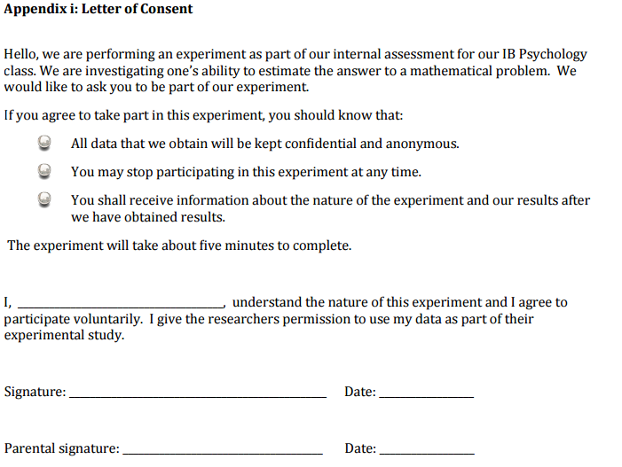

Sample consent form
• I have been informed about the nature of the research.
• I understand that I have the right to withdraw from the research at any time, and that any information/data about me will remain confidential.
• My anonymity will be protected as my name will not be identifiable.
• The research will be conducted so that I will not be demeaned in any way.
• I will be debriefed at the end of the research and will have the opportunity to find out the results at a later date.
I give my informed consent to participating in this research.
Name: ________________________________________
Date: _________________________________________
Contact number: ________________________________

